**Assignment 11.3**

Write a Pig UDF to find the tweets posted by @realDonaldTrump from the given dataset.

**UDF**

**LOGIC USED UDF TO FILTER THE TWEETS BY DONALD TRUMP AS SHOWN AND MADE A COUNT**

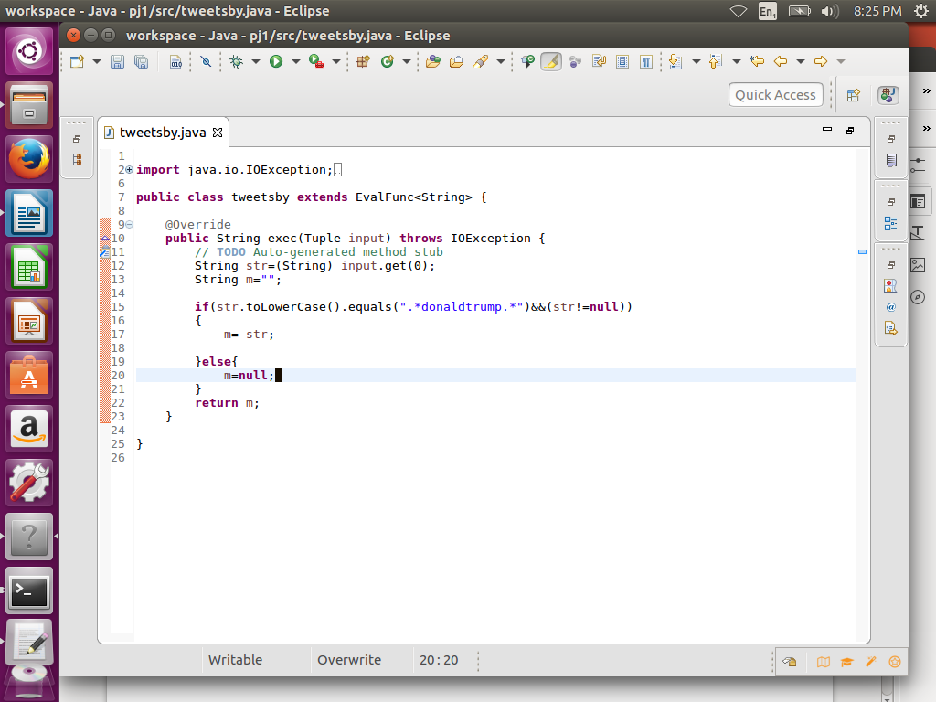

**PIG COMMANDS**

**LOGIC:** load the data and then used tweetby function of udf (Step d) to filter tweets by trump

**STEP1:** REGISTER UDF

**Step2:** load a using schema as shown

**Step3:** foreach A generating tweetsby(handle) which will perform filtration according to udf

**Step4:** group by Donald trump and made a count

**OUTPUT**

3218

